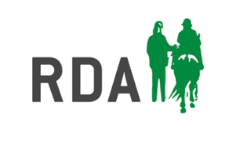
Group name:
Contact name for grant:
Contact email address:
Contact telephone number:
Has the group received a TAF Grant previously: Yes / No
Current Application information
Date travel cost incurred: Travel cost claim amount £
Details of nature of travel cost incurred: (e.g. trailer hire cost to attend regional qualifier or names of volunteers carsharing to training day)

Evidence provided (please attach scanned receipts and/or complete mileage log below)
Mileage Log
Starting postcode | Destination postcode | miles | @55p | £ claim

Bank account for payment of grant if successful

Bank account name:
Bank sort code:
Bank account number:

Once Completed
Email this form along with scans of any receipts to Suzanne Brown rceast@rda.org.uk

