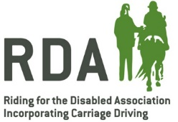
RDA East Region Expense Claim Form
Period : Date of claim:
Name :
Address:
Bank details for payment
A/C name: | Sort code: | A/C number:
Mileage
Date | Journey details | Mileage | @55p per mile | Total £
Total mileage
Other expenses
Date | Details | £
 | Total other expenses

Please return form to: hertsrda@btinternet.com with copies of receipts attached as required

