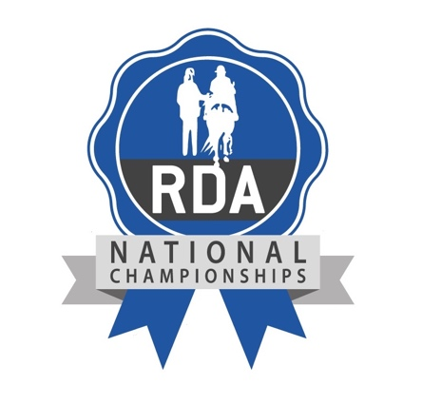
EAST REGION

Regional Dressage Qualifier

Regional Countryside Challenge Qualifier

East Region Fun Classes

ON

Sunday 24th May 2026

AT


Landbeach Road,
Milton, Cambridge CB24 6DB



Entries via Horsemonkey
Event Number 84982
Entries close 6PM Friday 8th May 2026

RIDING FOR THE DISABLED ASSOCIATION IS A REGISTERED CHARITY NO. 244108 / COMPANY LIMITED BY GUARANTEE NO. 501039

Please note that the Qualifying Show will be run in accordance with the 2026 Rule Book which is available in the National Championships section of the myRDA website.

Your attention is also drawn to the important information below.

- All horses/ponies coming to the College of West Anglia must travel with their valid passport and original Equine Influenza Vaccination Record and have had their last vaccination within 6 months. Documents and microchips will be checked at the gate before entry is allowed. A photocopy of the passport & all pages of the vaccination record must be uploaded with the entry. Please read the RDA rules on vaccinations carefully.
- Groups must consult the RDA weight chart and ensure that horse/rider combinations are suitable and comply with the weight chart before entering. RDA reserves the right to check any rider/horse combination considered not to comply with the limits set out on the weight chart. If a combination is found to be outside the parameters, action may be taken. This applies to coaches and volunteers as well as competitors.
- Rider numbers will only be issued at the Secretary’s Tent once the rider’s hat has been checked and if necessary tagged (pink) as being of the correct standard. Current hat standards are in the Rule Book. Groups are reminded to check any hats owned by riders and those worn by volunteers.
- Groups should check that their helpers, riders and supporters are aware they may be included in publicity photos. Should anybody wish to opt out of this they are to indicate this on their entry or fill in the relevant form at the Secretary’s table on the day.
- Riders who qualify should intend to compete at the National Championships. The option to compete hors concours is available.
- Riders must be a member of an RDA group. Own Horse Participants (previously known as Independent Participants) and riders from RDA Approved Centres will ride in the Open classes. They must adhere to the new rules including new paperwork and an annual suitability check by a regional representative (2025 Rulebook p16-19). Own Horse Participants and their groups are advised to start this procedure as soon as possible. Riders from RDA Approved Centres are invited to enter open classes.
- Rosettes will be given to those placed 1st – 6th in each section of a class. Each rider in the Countryside Challenge will receive a completion rosette.
- Please remember that each horse may only enter a maximum of five ridden classes including lead rein each day. These must not comprise of more than four in any one discipline. A horse is only permitted to be entered in the same class a maximum of 3 times.
- The event will be covered by RDA UK Insurance, groups should note that this does not cover travel to and from Milton. Our Regional Vet will be in attendance as will an Emergency Medical Technician and an Event Safeguarding Lead. Their names and pictures will be displayed at the Secretary’s tent.
- This is a fun event made possible by the generosity of the College of West Anglia and the good will of many volunteers. As such everyone attending is asked to abide by the Competition Code of Conduct. Stewards are there for your safety, please listen to them. Out of courtesy please ensure that droppings are picked up and that no horseboxes are cleaned out on site.
- Competing groups must nominate a helper to act as an event volunteer for the day.
- Groups are welcome to bring a picnic. Burgers, cake, ice creams and drinks will be available to buy.

ENTRY FEE IS £10.00 FOR ALL CLASSES

Entries are via Horsemonkey - RDA East National Championships Qualifier (84982)

and close 18.00 FRIDAY 8th MAY 2026

PLEASE NOTIFY SUZANNE BROWN OF ANY CANCELLATION OR CHANGE OF PONY OR RIDER IN ANY CLASS. Mobile: 07971 967739 / email hertsrda@btinternet.com

Regional Dressage Qualifier Schedule

This is a Regional Qualifying event for competitors who wish to qualify for the National Championships and who are prepared to attend. The championships will be held at Hartpury College, Gloucestershire, on 10th, 11th & 12th July 2026.

A rider may only enter one qualifying test, any other test must be entered hors concours, indicated at entry. All classes will be split into Junior & Senior sections.

Qualifying - Riders must score 60% or more. In each section (J/S) of each class the top 2 qualify, sections with 10 or more entries 3 qualify

Junior Riders – May compete as Juniors until the end of the year in which they reach the age of 16
Senior Riders – Riders over the age of 16.
Open Riders – Riders and equines who have been RDA Class Champion for two years; or compete in FEI, BD Para at Silver Level or above; or are an Own Horse Participant; or ride with an RDA Approved Centre.

The National Championships section of the myRDA website contains the 2026 Rule Book. Copies of all tests can be found at the bottom of the Dressage section.

DRESSAGE CLASSES

Riders with a profile
1 Grade 1 Grade 1 Championship Test (2022)
2 Grade 1 Open Grade 1 Open Championship Test (2025)
3 Grade 2 Grade 2 Championship Test (2022)
4 Grade 2 Open Grade 2 Open Championship Test (2025)
5 Grade 3 Grade 3 Championship Test (2022)
6 Grade 3 Open Grade 3 Open Championship Test (2025)
7 Grade 4 Grade 4 Championship Test (2022)
8 Grade 4 Open Grade 4 Open Championship Test (2026)
9 Grade 5 Grade 5 Championship Test (2022)
10 Grade 5 Open Grade 5 Open Championship Test (2025)

Available to riders without a profile
11 Grade 6 (walk only) Grade 6 Walk Only Championship Test (2022)
12 Grade 6 Open (walk only) Grade 6 Walk Only Open Championship Test (2025)
13 Grade 6 (walk & trot) Grade 6 Walk & Trot Championship Test (2022)
14 Grade 6 Open (walk & trot) Grade 6 Walk & Trot Open Championship Test (2025)
15 Grade 6 (canter) Grade 6 Canter Championship Test (2025)
16 Grade 6 Open (canter) Grade 6 Canter Open Championship Test (2025)

Riders in Grade 7
17 Grade 7 (walk only) Grade 7 Walk Only Championship Test (2022)
18 Grade 7 Open (walk only) Grade 7 Walk Only Open Championship Test (2025)
19 Grade 7 (walk & trot) Grade 7 Walk & Trot Championship Test (2022)
20 Grade 7 Open (walk & trot) Grade 7 Walk & Trot Championship Test (2022)
21 Grade 7 (canter) Grade 7 Canter Championship Test (2022)
22 Grade 7 Open (canter) Grade 7 Canter Open Championship Test (2026)

Led classes
23 Led (walk only) Introduction to Dressage Championship Test Walk Only (2022)
24 Led Open (walk only) Introduction to Dressage Championship Test Walk Only (2022)
25 Led (walk & trot) Introduction to Dressage Championship Test Walk & Trot (2022)
26 Led Open (walk & trot) Introduction to Dressage Championship Test Walk & Trot (2022)

Continues…

DRESSAGE CLASSES cont.
Riders with a Visual Impairment – please indicate your classification B1, B2, B3, B4 or B5 on your entry as these will be separate classes.

27 B1 - B5 Led (walk only) B1, B2, B3, B4, B5 Championship Test with Leader Walk Only (2026)
28 B1 - B5 Led Open (walk only) B1, B2, B3, B4, B5 Championship Test with Leader Walk Only (2026)

29 B1 - B5 Led (walk & trot) B1, B2, B3, B4, B5 Championship Test with Leader Walk & Trot (2026)
30 B1 - B5 Led Open (walk & trot) B1, B2, B3, B4, B5 Championship Test with Leader Walk & Trot (2026)

31 B1 - B5 (walk only) B1, B2, B3, B4, B5 Walk Only Championship Test (2025)
32 B1 - B5 Open (walk only) B1, B2, B3, B4, B5 Walk Only Championship Test (2025)

33 B1 - B5 (walk & trot) B1, B2, B3, B4, B5 Walk & Trot Championship Test (2025)
34 B1 - B5 Open (walk & trot) B1, B2, B3, B4, B5 Walk & Trot Championship Test (2025)

35 B1 - B5 (Canter) B1, B2, B3, B4, B5 Canter Championship Test (2025)
36 B1 - B5 Open (Canter) B1, B2, B3, B4, B5 Canter Championship Test (2025)

ENTRY FEE IS £10.00 FOR ALL CLASSES

Entries are via Horsemonkey ONLY - RDA East National Championships Qualifier (84982)

and close 18.00 FRIDAY 8th MAY 2026

PLEASE NOTIFY SUZANNE BROWN OF ANY CANCELLATION OR CHANGE OF PONY OR RIDER IN ANY CLASS. Mobile: 07971 967739 / email hertsrda@btinternet.com

Regional Countryside Challenge Qualifier Schedule

This is a Regional Qualifying event for competitors who wish to qualify for the National Championships and who are prepared to attend. The championships will be held at Hartpury College, Gloucestershire, on 10th, 11th & 12th July 2026.

Classes will be split into Junior, Senior & Open sections.

Qualifying - Riders must achieve 65% or more. In each section of each class the top 2 qualify but if there are more than 10 entries then 3 riders qualify, if more than 15 entries then 4 qualify.

Junior Riders – May compete as Juniors until the end of the year in which they reach the age of 16.
Senior Riders – Riders over the age of 16
Open Riders - Riders and equines who have been RDA Class Champion for two years; or are an Own Horse Participant; or ride with an RDA Approved Centre.

Copies of the Countryside Challenge course and the 2026 Rule Book are available in the National Championships section of the myRDA website. Leaders must lead at the 3rd stage of leading and wear riding hat and gloves. Sidewalkers must not be in contact with the rider.

Arena walks for equines:
Times for equine arena walks will be posted, they can only take place at these specified times. Equines can be walked up and down the arena but not along the course itself. When equines are being led, then they must be in a bridle and leaders must be in hat and gloves. There will be separate times for participants to walk the course.
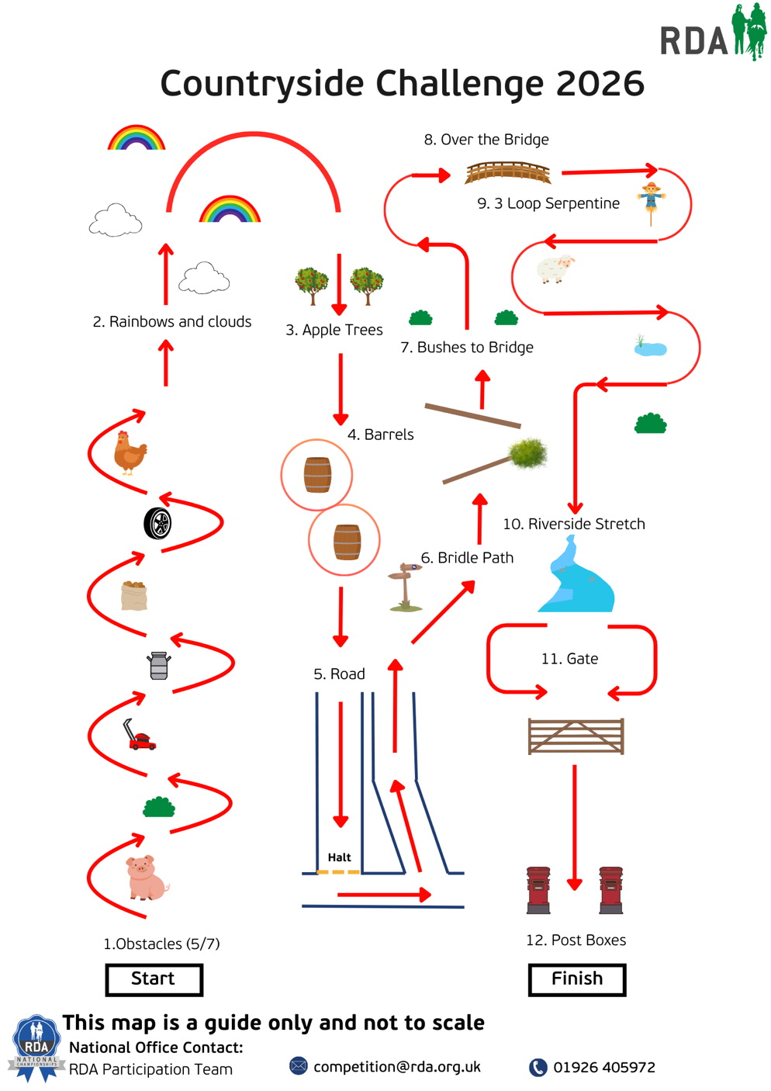

Please note that the
finals will take place
indoors so the size of
our course will reflect
this.

Continues…

COUNTRYSIDE CHALLENGE CLASSES

Riders with helper(s)

40 Led with 1 sidewalker
41 Open Led with 1 sidewalker

In classes 18 and 19 if the helper is a side walker then they are to carry a lead rope

42 Riders with 1 helper, either leader or side walker
43 Open Riders with 1 helper, either leader or side walker

44 Riders with a Visual Impairment, led with 1 sidewalker
45 Open Riders with a Visual Impairment, led with 1 sidewalker

In classes 46 and 47 if the helper is a side walker then they are to carry a lead rope

46 Riders with a Visual Impairment with 1 helper, either leader or side walker
47 Open Riders with a Visual Impairment with 1 helper, either leader or side walker

Independently ridden

A helper must stand in the arena with a lead rope in case of emergency and may call the course as in course instructions under COMMANDERS.

48 Independently ridden
49 Open Independently ridden

50 Riders with a Visual Impairment, independently ridden
51 Open Riders with a Visual Impairment, independently ridden

ENTRY FEE IS £10.00 FOR ALL CLASSES

Entries are via Horsemonkey ONLY - RDA East National Championships Qualifier (84982)

and close 18.00 FRIDAY 8th MAY 2026

PLEASE NOTIFY SUZANNE BROWN OF ANY CANCELLATION OR CHANGE OF PONY OR RIDER IN ANY CLASS. Mobile: 07971 967739 / email hertsrda@btinternet.com

Non Qualifying East Region Fun Competitions

In all fun dressage competitions classes will be split into Junior and Senior sections.

Junior Riders – May compete as Juniors until the end of the year in which they reach the age of 16
Senior Riders – Riders over the age of 16

East Region Introduction to Dressage

Those who have competed in the East Region Dressage before should consider entering the qualifying dressage classes. Riders may enter either the Walk Only or the Walk & Trot test.

In these fun dressage classes riders may opt to have sidewalkers

60 Led (walk only) Introduction to Dressage Championship Test Walk Only (2022)
61 Unled (walk only) Introduction to Dressage Championship Test Walk Only (2022)

62 Led (walk & trot). Introduction to Dressage Championship Test Walk & Trot (2022)
63 Unled (walk & trot) Introduction to Dressage Championship Test Walk & Trot (2022)

Unfortunately we are unable to offer freestyle to music classes

Non Qualifying Countryside Challenge

Open to any rider not competing in a qualifying class.

64 Rider any age with leader and 2 sidewalkers

ENTRY FEE IS £10.00 FOR ALL FUN CLASSES

Entries are via Horsemonkey ONLY - RDA East National Championships Qualifier (84982)

and close 18.00 FRIDAY 8th MAY 2026

PLEASE NOTIFY SUZANNE BROWN OF ANY CANCELLATION OR CHANGE OF PONY OR RIDER IN ANY CLASS. Mobile: 07971 967739 / email hertsrda@btinternet.co

On the day – FREE Have a go ART AREA

Don’t forget to find the Art area, draw a picture, do some colouring in,
design a rosette. Open to all

There will be a display of regional entries for the RDA National Championships Arts & Crafts Classes. (see separate schedule)

*********************************************

On the day – FREE Have a go HORSE CARE COMPETITION

Suitable for all levels, based on RDA Proficiency Tests 1 – 4. Come along and have a go.

Open to all RDA participants on the day

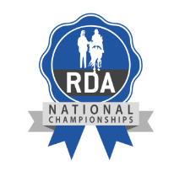

RDA East Competition Code of Conduct for
Volunteers, Competitors and their Supporters

We are fully committed to safeguarding, equine welfare and promoting the wellbeing of everyone involved and wants to ensure a positive and enjoyable experience for all.

When attending competitions, everyone is expected to abide by the following code of conduct:

- All competitors and/or their carers must take responsibility for ensuring theyare up to date with the rules, understand and adhere to them.

- All competitors, carers and supporters should recognise the valuable contribution made by all officials, who are usually volunteers. They give their time and resources to enable this event to happen.

- All participants, carers and supporters must respect officials and their decisions.

- All officials must treat everyone equally and with dignity.

- All those attending the qualifier should treat others with the same level of respect that they would expect to be shown to themselves.

- Everyone must respect the rights, dignity and worth of all, regardless of age, gender, ability, race, cultural background, religious beliefs or sexual identity.

- Everyone must ensure that inappropriate language or behaviour is challenged.

If you have a concern:-

If anyone has a concern leading up to the event, they should please refer either to their RDA Group Safeguarding Officer or contact RDA UK’s Lead Safeguarding Officer via my-rda.org.uk or on 01926 492915. If you have concerns on the day please refer to the Event Safeguarding Officer whose photo and name will be displayed at the Secretary’s tent.

