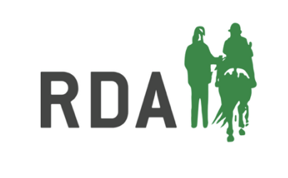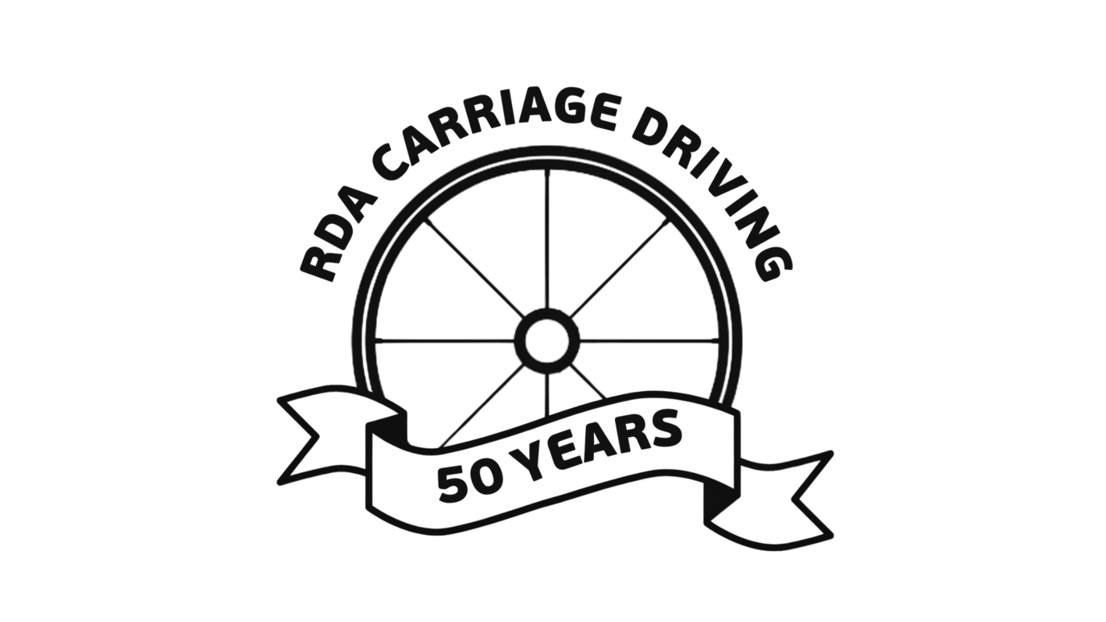

**EAST REGION TRAINING DAY**

**Extending your Reach –**

**Mentor training for RDA Coaches**

An interactive workshop

led by

RDA Advanced Coach Kady Chatman

**Sunday 9th November 2025**

**10.00am - 3.00pm**

**at**

**Whittlesford Memorial Hall**

**Mill Lane**

**Whittlesford**

**Cambridge**

**CB22 4NE**

Learning outcome: Understand how all RDA Coaches are mentors within their groups. Gain confidence and techniques to improve your mentoring skills.

This workshop introduces practical tools and techniques to boost your confidence and coaching skills. You will learn strategies for supporting other members of the RDA community such as newer coaches and volunteers.

The session is suitable for all RDA Coaches, including Group Coaches, Driving Coaches and Coach Developers.

All applications to be sent directly to Suzanne Brown at: [hertsrda@btinternet.com](mailto:hertsrda@btinternet.com?subject=Mentoring%20Workshop%20application) Please include your **name, coaching qualification** and **group**. Successful applications will be acknowledged along with details of how to pay. Cost of the day is **£10**.

Application to arrive no later than **Wednesday 5th November**

Numbers are limited to 30 so please apply promptly.